Requirements

1. LOAD for texting
2. USB Modem (Driver installed)
3. Database ON (MySQL)

GUI (Graphical User Interface)

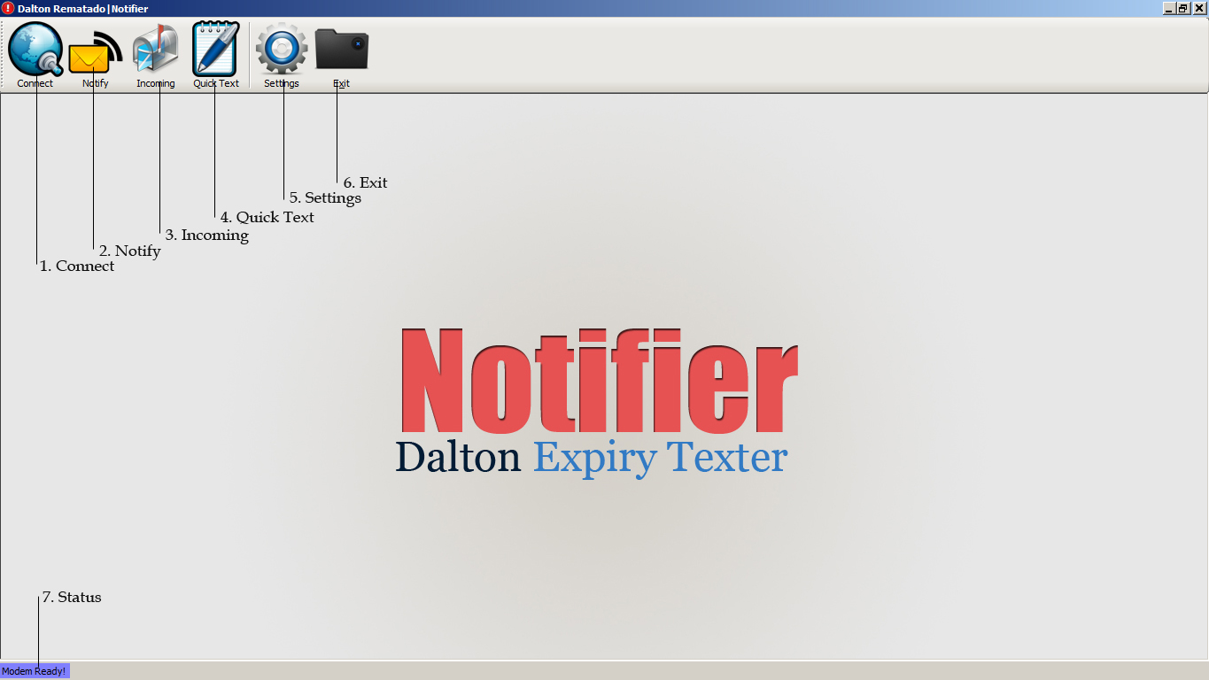

1. Connect Button – to Connect the Software and the USB Modem. If the Status (7) is “Modem Ready”, it means a modem was found and ready to connect. If not, check your Settings (5).
2. Notify Button – Where you send Notification to the Expiry List from the Branch.
3. Incoming Button – Serve as your INBOX
4. Quick Text Button – Composed a message
5. Settings Button – Configure your device and database.
6. Exit Button – to Close the Application
7. Status Bar – display any information about the device.

Setup

1. **Install the USB MODEM**  
   Install the USB Modem and its driver. Make sure that the PORTS are already installed. Try activating the USB Modem on its default software.
2. **Turn ON the database**  
   Make sure that the **Database is ON** when using the Dalton Expiry Notifier, so that the incoming messages will be stored.
3. 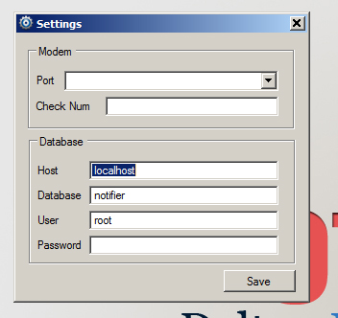**Setup the System Settings**Open the software, click the Settings button.  
   Assign a PORT to the USB Modem, Add a Check Number (Cellphone) for the Notifications Update, Add your Database Information like Host, Database, User and Password. And click Save.

How to Use

1. Click Connect  
   Check if the Status bar (7) indicates “Modem Ready!” so that you can connect to the device and changed the status into “Modem Connected!”. If failed, check your Settings (5).
2. Click Notify Button (2) to send notifications.
3. File Loader  
   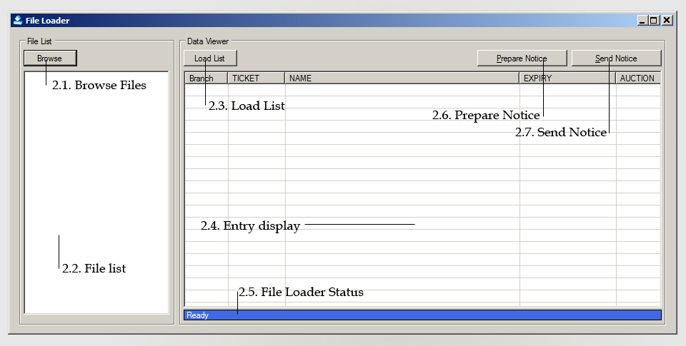
4. Click Browse Button (2.1.) to browse file from Branch. After selecting files, it will display the file loaded at the File list (2.2.), removing files is just clicking it and press DELETE.
5. Click the Load List Button (2.3.) to Load all the data from the file to the Program. Loaded data will be display at the Entry display (2.4.).
6. To prepare a notice, compose a notice by clicking the Prepare Notice Button (2.6.).
7. After the entries has been loaded and the composed message is saved. Click the Send Notice (2.7.) to start sending notice.
8. All information about sending of notification will be display at the File Loader Status Bar (2.5.). System will be sending information also at the Check Num entry.

Other Function

1. Inbox  
   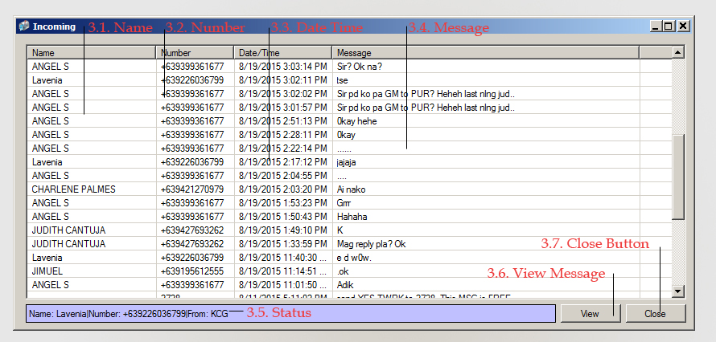
2. Quick Text  
   